# NOMINATIONS / ELECTIONS POLICY

|  |
| --- |
| **INTENT**  The Alberta Library has an appropriate process for election of members to its Board of Directors in accordance with the Articles of Association. |
| DEFINITIONS “Director” means a member of the Board of Directors.  “Member” means an institution or library in Alberta that is listed in the Register of Members.  “Proxy” means the person designated by a Member to be its representative for voting  purposes at meetings of the Members. |
| POLICY Directors are elected by the proxies at the Annual General Meeting. |
| Nominations:  * A Nominations/Elections Committee (“the Committee”) is appointed by the Board. * The committee calls for nominations for positions to be filled in that year. * Candidates must be nominated by a Proxy. * All nominations must include the consent of the nominee. * Nominations will also be received from the floor at the AGM. |
| Elections:  * The committee will declare nominations open at the AGM and invite nominations from the floor. * If there is only one candidate for a position, they shall be deemed elected. * Voting shall be online using a confidential process, managed by a TAL staff member. * Only proxies may vote. * If there is a tied vote, the Chair shall have an additional vote. * Election results will be announced immediately after the votes are counted.   Newly elected Directors take office at the conclusion of the meeting at which they were elected. |
| Midterm vacancies:  * If a vacancy occurs less than three months before the AGM, the position will remain vacant until a replacement is elected at the AGM. * If a vacancy occurs three months or more before the AGM, the Board may appoint a member from among   the proxies in accordance with the representative category requirements. |
| Terms of Office: The maximum a Director may serve in any position is four consecutive years. The Chair serves for one term of two years, plus one year as Past Chair.  The terms of office are staggered to provide continuity and consistency. |
| Director Responsibilities: All directors are expected to participate actively in the work of TAL’s board, including   * 1. The definition of TAL’s mission   2. The adoption of a budget and providing financial oversight   3. Overseeing the work of the CEO   4. Ensuring legal integrity   5. Ensuring accountability to members   6. Enhancing TAL’s reputation.   This requires preparation for Board meetings and contributions that ensure that TAL benefits all segments of the library community. |
| Executive Officers Executive Officers are chosen at the first Board meeting after the AGM. The Positions available are Vice-Chair, Secretary, and Treasurer. They are chosen by self-nomination, or nomination by other Board members. |
| Terms of Office/Election Calendar Chair Odd numbered years  Past Chair. Odd numbered years  Member-at-Large 1 Odd numbered years  Member-at-Large 2 Even numbered years  Member-at-Large 3 Odd numbered years  Publicly Funded University Institution Member Even numbered years  Publicly Funded College/Polytechnic Institution Member Odd numbered years  Independent Post-Secondary Institution Member Even numbered years  Public Libraries Representative Even numbered years  Regional Library Systems Odd numbered years |

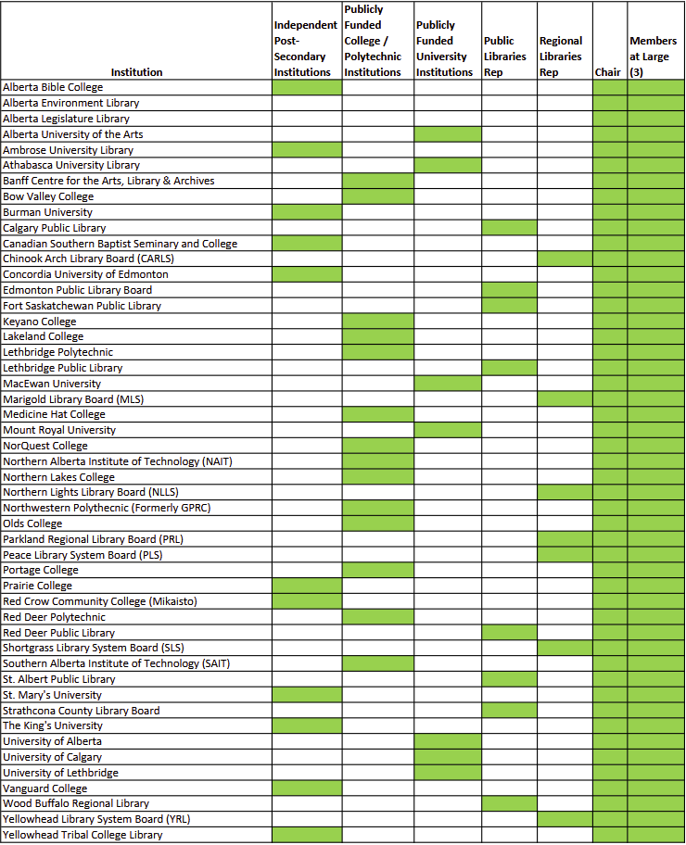

# RELATED DOCUMENTS

* + - *Nominations/Elections Committee Terms of Reference*

*Approval date: 2025-04-25*